**FUNDING FORMULA STAGE 1: BUILDING CAPACITY**

**SWOT ANALYSIS TOOL**

1. **What is a SWOT Analysis?**

A SWOT Analysis is a useful technique for understanding your Member Association’s Strengths and Weaknesses, and for identifying the Opportunities open to you and the Threats that you face. What makes SWOT particularly powerful is that, with a little thought, you can discover opportunities that your Member Association is well-placed to exploit. And by understanding your weaknesses, you can limit or eliminate threats that would otherwise undermine your Member Association.

More than this, by looking at your Member Association and your competitors using the SWOT framework, you can build a strategy that helps differentiate you from your competitors, so that you can compete successfully in your market. Words in **bold colour and underlined** are further tools that you will find in Appendices at the end of this document, or online.

1. **How to use a SWOT Analysis**

Your Member Association can use a SWOT Analysis (i) as a simple icebreaker helping people to “kick off” a strategy discussion, or (ii) in a more sophisticated and meaningful way as a serious strategy tool. To help you to carry out your analysis, download and print off the **worksheet** in Appendix I.

***Tip***

* ***Look at your Member Association’s strengths and see if they present any opportunities***
* ***Look at your Member Association’s weaknesses and see if you could open up opportunities by eliminating them***
* ***Look at your Member Association’s threats and see if any can be turned into opportunities***

1. **Further SWOT tips**

If you are using SWOT as a serious tool, make sure you apply it rigorously:

* only accept precise, verifiable statements, for example “cost advantage of $10/box of contraceptives”, rather than "good value for money"
* ruthlessly cut long lists of factors, and [**prioritize**](https://www.mindtools.com/pages/article/newHTE_92.htm) them, so that you spend your time thinking about the most important factors
* use the SWOT analysis in conjunction with other [**strategy tools**](https://www.mindtools.com/pages/main/newMN_STR.htm) (for example, [**USP Analysis**](https://www.mindtools.com/pages/article/newTMC_11.htm)  and [**Core Competence Analysis**](https://www.mindtools.com/pages/article/newTMC_94.htm) ) so that you get a comprehensive picture of the situation you're dealing with

***Tip***

***When looking at opportunities and threats, a* PESTLE Analysis *(which looks at Political, Economic, Social, Technical, Legal and Environmental issues) can help you include external factors you may otherwise overlook, for example government regulations or technological changes – see more in Appendix III***

**APPENDIX I: SWOT Analysis Worksheet**

Remember that your strengths and weaknesses are internal factors affecting you, and opportunities and threats are external factors affecting you.

|  |  |
| --- | --- |
| **Strengths** | **Weaknesses** |
| 1. what does your Member Association do well? 2. what does your Member Association do better than anyone else? 3. what advantages does your Member Association have? 4. what unique resources can you draw on? 5. what do others see as your strengths? 6. what factors mean that you "get the sale" –    * why do clients choose your services?    * why do donors give you funding? 7. what are your Member Association’s **Unique Selling Points** (USPs)? | 1. what could your Member Association improve? 2. what should you avoid? 3. where do you have fewer resources than others? 4. what do others see as your weaknesses? 5. what factors lose you clients and/or funding? |
| **Consider your strengths from:**   1. an internal [perspective 2. from the point of view of your clients 3. from the point of view of your competitors   from the point of view of your donors | **Consider your weaknesses from:**   1. an internal and external basis: do other people seem to perceive weaknesses that your Member Association doesn’t see? 2. your competitors’ perspective – are they doing better than you? 3. It is best to be realistic now, and face any unpleasant truths as soon as possible. |
| **Opportunities** | **Threats** |
| 1. what opportunities are open to your Member Association? 2. what trends could you take advantage of? 3. how can you turn your strengths into opportunities? | 1. what threats could harm your Member Association? 2. what is your competition doing? 3. what threats do your weaknesses expose you to? 4. what obstacles does your Member Association face? |
| **Useful opportunities can come from:**   1. changes in technology – these could help you reach new clients 2. changes in relevant government policy – these could open up new markets 3. changes in social patterns, population profiles, lifestyles changes, and demographics 4. local events 5. changes in national and/or global funding | **Threats can present themselves in the following ways:**   1. changing quality standards/specifications for your job, products or services 2. changing technology that threatens your position? 3. debt or cash-flow problems/increases to rents, interest rates or procurement costs 4. changes in national and/or global funding 5. deregulation that exposes you to intensified competition 6. a shrinking market |

**APPENDIX II: Your Member Association’s Unique Selling Points (USPs)**

1. **What is a USP?**

Your USP is the unique asset that your Member Association has, and your competitors do not. In USAID-speak, these are also known as differentiators: criteria that make your Member Association different from everyone else. It is also known as your:

* competitive edge
* speciality or niche area of work
* core competencies
* comparative advantage

1. **How to use a USP Analysis**

First, think about what clients (and donors!) value about your products or services, and about those of your competitors. Look at the reasons why clients use your services and why donors fund you (you will have done this in your **Competitor Analysis**).Talk to your service delivery teams, finance teams, monitoring & evaluation teams, management teams and, most importantly, to clients themselves so that you have everyone’s perspective. Find out:

* what makes your Member Association stand out in its country
* something unique about your Member Association
* how your Member Association is best at addressing country-specific issues
* what your Member Association is known for
* what your Member Association is really good at/best at doing
* if your Member Association is the only one doing/delivering this
* if your Member Association is a centre of excellence, a leading provider of sexual and reproductive health in your country

1. **Rank your Member Association and competitors**

Being as objective as you can, score your Member Association and each of your competitors out of 10 for each characteristic. Where possible, base your scores on objective data. Where this isn't possible, do your best to see things from a customer's perspective and then make your best guess.

|  |  |  |  |  |
| --- | --- | --- | --- | --- |
| **Criterion** | **You (1 = poor / 10 = excellent)** | **Competitor # 1** | **Competitor # 2** | **Competitor # 3** |
|  |  |  |  |  |
|  |  |  |  |  |
|  |  |  |  |  |
|  |  |  |  |  |
|  |  |  |  |  |
|  |  |  |  |  |
|  |  |  |  |  |

1. **Identify where your Member Association ranks well**

Plot these points on a graph. his helps you spot different competitors' strengths and weaknesses – and yours! From this, develop a simple, easily communicated statement of your USP. Make sure everyone in your Member Association understands and agrees with it.

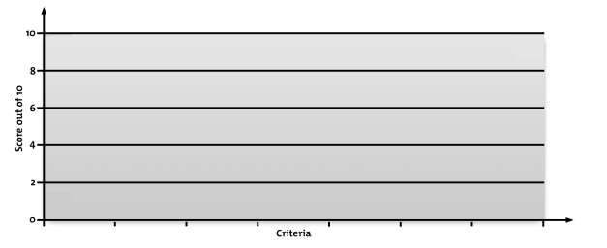

***Tip***

***When you identify your Unique Selling Point, make sure it’s something that really matters to clients and donors – there is no point in being the best for something they don’t care about!***

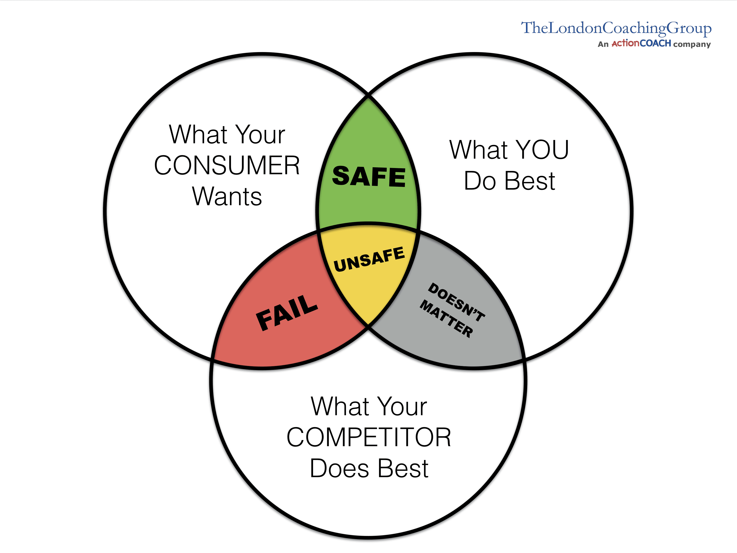

**Appendix III: PESTLE Analysis**

1. **What is a PESTLE Analysis?**

A PESTLE Analysis is a simple and widely used tool that helps you to assess the **P**olitical, **E**conomic, **S**ocial, **T**echnological, **L**egal and **E**nvironmental changes in your environment. This helps you to understand the changes that your Member Association is exposed to, and, from this, take advantage of the opportunities that they present.

1. **How to undertake a PESTLE Analysis**

Follow these steps to analyze your environment, and the opportunities and threats it presents.

**2.1 Political factors to consider**

* when is your country's next local, state, or national election? How could this change government or regional policy?
* who are the most likely contenders for power? What are their views on policies that could affect your Member Association?
* are there any other political factors that are likely to change?
* how does government approach corporate policy, corporate social responsibility, environmental issues, and customer protection legislation? What impact does this have, and is it likely to change?

**2.2 Economic factors to consider**

* how stable is your current economy: is it growing, stagnating, or declining?
* are key exchange rates stable, or do they tend to vary significantly?
* are levels of income rising or falling? Is this likely to change in the next few years?
* what is the unemployment rate? Will it be easy to build a skilled workforce, or will it be expensive to hire skilled labour?
* does your Member Association have easy access to credit? If not, how will this affect you?
* how is globalization affecting the economic environment?
* are there any other economic factors that you should consider?

**2.3 Social factors to consider**

* what is the population's growth rate and age profile? Is this likely to change?
* are generational shifts in attitude likely to affect what your Member Association is doing?
* what are your society's levels of health, education, and social mobility? How are these changing, and what impact do they have?
* what social attitudes and social taboos could affect your Member Association? Have there been recent socio-cultural changes that might affect this?
* how do religious beliefs and lifestyle choices affect the population?
* are any other socio-cultural factors likely to drive change for your Member Association?

**2.4 Technological Factors to Consider**

* are there any new technologies that your Member Association could be using?
* are there any new technologies on the horizon that could radically affect your work?
* do your competitors have access to new technologies that could redefine their products?
* in which areas do governments and educational institutions focus their research? Is there anything you can do to take advantage of this?
* are there existing technological hubs that you could work with or learn from?
* are there any other technological factors that you should consider?

**2.5 Legal factors to consider**

* how well developed are property rights and the rule of law, and how widespread are corruption and organized crime? Are these situations likely to change, and how is this likely to affect you?
* could any pending legislation or taxation changes affect your Member Association, either positively or negatively?
* how will business regulation, along with any planned changes to it, affect your Member Association? Is there a trend towards regulation or deregulation?
* what is the likely timescale of proposed legislative changes?

**2.6 Environmental factors to consider**

* is there growing awareness of environmental issues?
* how could these issues affect your Member Association?
* are there environmental issues that could help your Member Association’s work?